Fire Emblem is a strategy game based on fantasy scenes in some countries where there is a war. The game describes performing your soldier moves on a grid battlefield to defeat the enemy's commander without losing your troops. Furthermore, the game includes different types of units. It is simply a cycle that has competitive advantages against each other so it's important to choose which units can fight the enemy best. The game offers both types of play and direction to create a centralized countervailing style with the same style as the original version. The game genre is not related to luck in that the player has to calculate the data and the game module board. This entertaining game still has to capture the difficulty and tactical feel of the original series while playing with the feel of a board game.

Rules and mechanisms:

The game genre consists of 2 to 4 players and different units. Duration lasts about 15-20 minutes for 2 players and an additional 5-10 minutes for each additional player. The match progress is fast and all use tactics to play, so it is necessary to move and deploy the units properly.

Each player is granted 12 units and is given 4 units in each category of troops such as mages, knights, and cavalry. A chosen knight will be the commander and will receive 2 dice throws and 5 health.

Each turn the player will drop the dice and the number of points received will be the number of damage done. If the points are stronger than the opponent's health, the remaining points will be added to the score of the other unit. Besides, the normal unit will be teleported 3 times but the shield will be teleported to 5.

Mages can attack into 4 spaces to win and hit the leader.

Each Knight will receive 30 health, Cavalry 25 health, and the Mage will receive 15 health.

The cycle of military strength like Mage> Knight, Knight> Cavalry, Cavalry> Mage

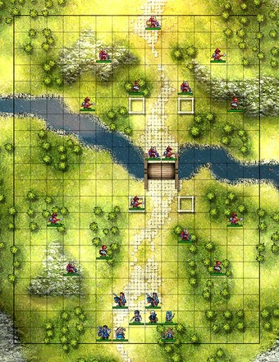

Moreover, players can choose the types of units that match the strategy of other players and take advantage of their strength.

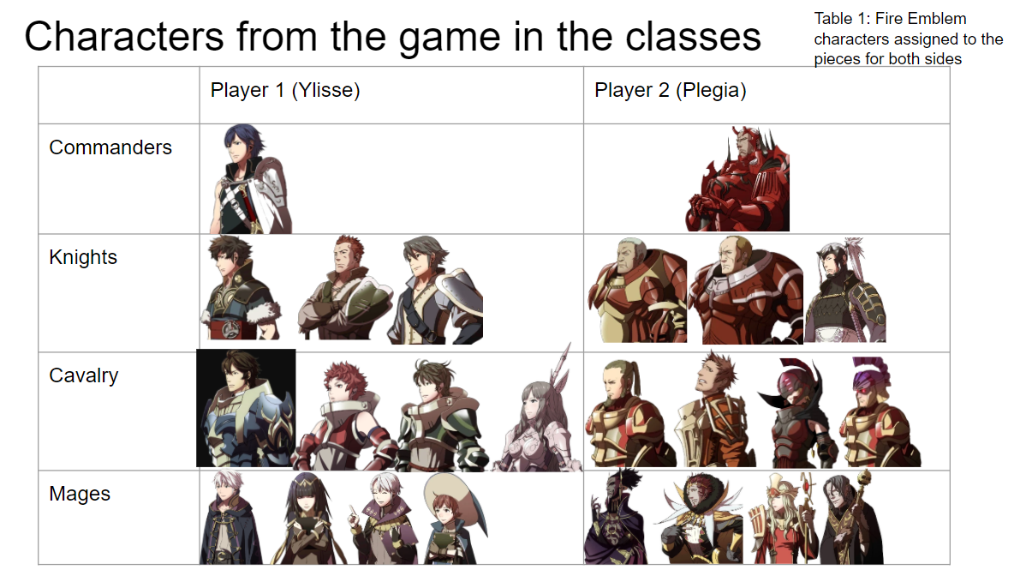

Players will be able to change strategic terrains through maps such as A, B, and C.

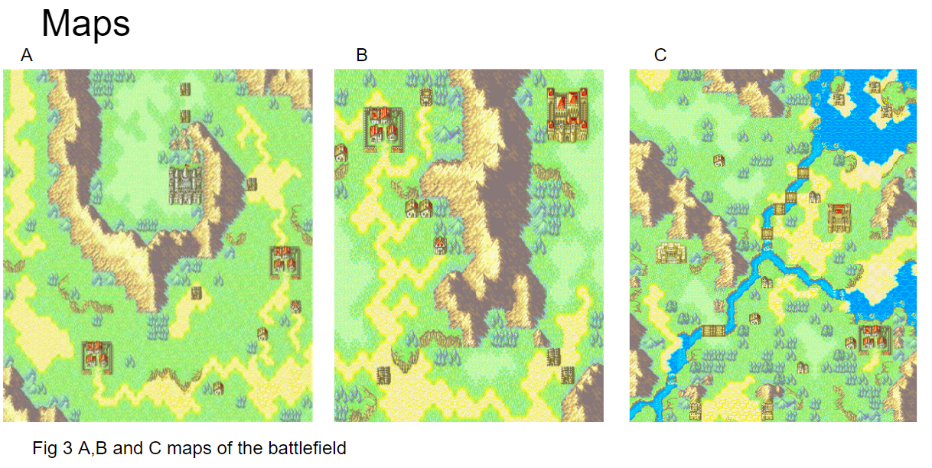

When testing and developing the game myself, I find it difficult to give instructions and logic for the game to work. Moreover, explaining and guiding players to understand the game's problems and obey the rules of the game is not easy. Besides, my personal experience is coming up with ideas about developing and upgrading an existing game model. However, there are still many shortcomings in giving opinions and disagreements. After going through a period of conflict, the team finally finished the idea and came up with a guide and reasonable rules to help players easily visualize and follow. After this lesson, I hope that each team member when researching a project needs to have a thorough study of the logic as well as the role and applicability of the individuals in the game, it is necessary to give positive feedback and available experience in conducting surveys on a player's wishes.

Team member: Muhammed Zulfqar, Jamie Soden, Alyssa Lamb, Huy Nguyen